Quantifying the “Cutting Signature”: A Multi-Algorithm Approach to Predicting ACL Injury Risk in Athletes
Moulik Jain^{#1}
#College of Information Sciences/Technology, The Pennsylvania State University, United States of America
¹mkj5514@psu.edu

Abstract- The number of anterior cruciate ligament (ACL) injuries in athletes is estimated to be around 200,000 per year in the United States, with a disproportionate impact on collegiate populations because of the high-intensity cutting and pivoting activities of competitive sport. This paper presents a machine learning pipeline to measure the Cutting Signature, a combination of three designed biomechanical proxy features (Fatigue Accumulation, Lateral Force Proxy, Symmetry Index), and a systematic six-way technique tournament to identify the best combination of class-imbalance treatment and probability calibration to deploy the system to clinical use. Three heterogeneous datasets of 6,430 athlete-seasons are integrated to a canonical 15-feature schema, which results in 10.6% injury prevalence (1:8.4 ratio). All six modular configurations swap precisely one block of the previous: SMOTE (T0, control) -> ADASYN (T1) -> BorderlineSMOTE (T2) -> Cost-Sensitive Learning (T3) -> Platt calibration (T4) -> Isotonic calibration (T5, proposed). Monotonic results on a 20% stratified hold-out indicate improvement in all measures: T5 attains AUC = 0.831, Recall = 0.846, F1 = 0.808, and Brier Score = 0.0741, a 25.6% improvement over the SMOTE control (BS = 0.0996) and 21.8% below the no-skill prevalence predictor. The isotonic-calibrated model meets the Clinical Trust property: a reported 65% risk score is associated with a 65% ACL injury rate in that score range that is empirically validated. Post-hoc SHAP analysis validates engineered Cutting Signature features in the highest importance positions. An example of a coach-facing 65%-threshold early-warning dashboard with a five-step Coach Action Protocol is shown, indicating athletes with calibrated, clinically meaningful probability estimates of targeted load modification.

Keywords- ACL injury prediction, machine learning, biomechanical feature engineering, SMOTE, cost sensitive learning, isotonic probability calibration, stacking ensemble, collegiate athletics, sports injury surveillance, clinical decision support.

- INTRODUCTION

Rupture of anterior cruciate ligament is among the most relevant musculoskeletal damages in competitive sports. In addition to the acute clinical repercussion of ACL tear, which includes reconstructive surgery, six to twelve months rehabilitation and high rate of re-injuries, there exist long-term functional impact of ACL tear: accelerated knee osteoarthritis, enduring psychological barriers to return-to-sport and, in the case of collegiate athletes, the end of competitive careers [1]. The scope of the problem in terms of its epidemiology is significant: in the United States alone, about 200,000 ACL reconstructions are carried out each year and the incidence rates of the problem are especially high in sports where it is necessary to quickly change directions, such as football, basketball and American football [2].
The biomechanical pathogenesis of non-contact ACL injury is well-known in literature. The injury process is filled with a certain motor pattern, the so-called cutting maneuver, which is characterized by single leg deceleration, lateral displacement of the trunk and asymmetrical ground reaction forces in a near-extended knee in dynamic valgus positioning. More recent studies by Jauhiainen [1] gave the name of a Cutting Signature: a multivariate kinematic-kinetic fingerprint, which is measurable in controlled cutting conditions, and which differentiates between athletes who and those who do not sustain an ACL injury. The current work is informed by this definition. In comparison to the Cutting Signature operationalized by Jauhiainen by full 3D motion capture instrumentation, i.e., force plates, retro-reflective markers sets and laboratory grade capture volumes, the current study hypothesizes that statistically equal discriminative power can be estimated using training-load and performance monitoring variables that are routinely measured in collegiate athletics programs and without special biomechanics equipment.

- Predicting Injuries: The Scalability Problem

The gold standard of the biomechanical evaluation of injury risk is three-dimensional motion capture (3D MoCap) [2], [3]. Nonetheless, its implementation on scale in the collegiate sports is not feasible. One athlete in a complete laboratory session takes 60 to 90 minutes of technician time, specialized equipment with a purchase price of more than 150,000 USD and clinical skills to place markers and model kinematics. Long-term screening cannot be conducted through such protocols in programs that cater to rosters of 20-80 athletes in more than one sport season. As a result, most collegiate sports medicine personnel use subjective clinical screening instrument (e.g., the Landing Error Scoring System) or functional movement screens, which have shown poor predictive validity in future studies of ACL injury [2].
Machine learning is a scalable alternative route. In the event that the risk of injury can be sensibly translated into features that can be obtained using GPS-tracked training loads, force plate free symmetry measures, and session by session recovery data, which most Division I and II athletic training personnel have already gathered, a validated classification pathway can be used to operationalize proactive risk stratification without the need to invest capital in biomechanics infrastructure. This is the core premise of the present work.

- Research Questions

This investigation will be informed by the following three research questions:

- RQ1: Is a combination of biomechanical proxy variables (Fatigue Accumulation, Lateral Force Proxy, Symmetry Index), designed based on the available training-load variables, serve as a computationally feasible surrogate of laboratory-based Cutting Signature components in the classification of ACL injury?

- RQ2: Does a Stacking Ensemble of heterogeneous tree-based learners (Random Forest, XGBoost, LightGBM) trained on a multi-cohort, cross-gender dataset perform better (Mean AUC-ROC > 0.75) than the individual base learners, when SMOTE is used only in training folds to overcome the 1:8 class imbalance?

- RQ3: Is it possible to convert probabilistic performance of the most effective model into a coach-actionable and early-warning strategy that can be used to stratify athletes into clinically meaningful levels of risk without causing compensatory behavioral changes in monitored athletes?

- Contributions

There are three main contributions of this work. To begin with, a multi-dataset pipeline that can be replicated in the future is presented, which aligns three diverse public datasets, 6,430 athletes in different sport settings and genders, to a single 15-feature canonical schema. Second, a strict assessment system using 10-fold Stratified Cross-Validation using fold-internal SMOTE is used, which directly resolves the methodological issue of data leakage that was raised in previous ensemble-based sports injury prediction research. Third, a realistic Translation layer, the Coach Action Protocol, is illustrated, transforming continuous injury probability scores into a three-level risk classification system (GREEN < 35%; AMBER 35-65%; RED > 65%) that has been tuned to be used in the field of collegiate athletic training.

- RELATED WORK

- Prospective ML for ACL Injury: Jauhiainen (2022)

The most methodologically relevant prior work is the study by Jauhiainen [1] who studied 880 female elite handball and soccer athletes during one competitive season and reported 60 ACL injuries (7.6% incidence). The laboratory-based cutting tests identified 283 biomechanical variables used in the analysis and the model zoo-linear SVM, k-nearest neighbors, Random Forest and gradient boosting variations were used that were evaluated by 100-repetition Stratified Cross-Validation. The best model was a Linear Support Vector Machine with a mean AUC-ROC of 0.63 (range: 0.55-0.67), showing that biomechanical signal prediction of potential ACL injury is a difficult classification task, despite the high-fidelity 3D motion capture data and large feature sets.
In the current work, there are two methodological findings of this study, which directly inform the present work. The former was that the classification performance of the cohort that the authors were dealing with did not improve, perhaps because the dimensionality of features (283 variables) was too large to introduce synthetic noise in the over-sampled minority population. This drawback will become less evident in the lower-dimensional feature space of the current project (15 variables); SMOTE can only be trained to folds to eliminate leakage as an intervening variable. Second, the emphasis on repeated Cross-Validation to identify the nature of variance predetermines the use of 10-fold Stratified CV with the mean and standard deviation reporting in this case. The biggest distinction that the current work offers over that of Jauhiainen is scalability: their pipeline requires full laboratory 3D MoCap equipment, whereas the current pipeline is designed to be implemented only based on training load monitoring data.

- Wearable-Sensor Approaches: Taborri (2021)

Taborri [2] has investigated the classification of the risk of ACL injury using the wearable inertial measurement unit (IMU) and the Landing Error Scoring System (LESS) as a supervised labeling protocol in a cohort of 39 female college basketball players. The most informative feature by Mean Decrease in Accuracy (MDA = 49.2%), was the area of ellipses of the center-of-pressure trajectory, which was used to train Linear SVM, with the rest of the features ranking in the order of their discriminating ability as will be seen below.
The conceptual impact of this discovery on the ongoing research in the design of the Lateral Force Proxy feature (LFP = speed x (1 - symmetry), clipped to [0, 1]) which employs a lateral asymmetry as a product of locomotion intensity and bilateral imbalance, which is a proxy of center of pressure excursion without the force-plate hardware, has been thought of as follows: The fact that Taborri undertook a small sample (N = 39) is the main weakness of the study as it is impossible to estimate the AUC-ROC in the population on a large scale and it is more challenging to extrapolate the study findings to other sports or even to male populations.

- Random Forest in Male Collegiate Athletes: Guo (2025)

Guo [3] studied ACL injury prediction in a prospective cohort of 104 male collegiate basketball players with 12-month follow up, recording 11 ACL injuries (10.6% incidence, which is the same incidence as the aggregate incidence in the fused dataset of the present study). The authors obtained the AUC-ROC = 0.80 with the help of a Random Forest classifier based on 3D MoCap-derived joint moments and the Y-Balance Test (YBT) composite scores. Feature importance analysis (Gini Impurity) identified increased left knee flexion moment in the early-stance position (Gini = 0.0928), increased left knee internal rotation moment in the initial-acceptance position (Gini = 0.0824), YBT left leg composite score and weekly training hours more than 15 hours as the top predictors. SMOTE was used to do the class imbalance remediation alongside Gaussian noise augmentation.
Two significant cutoffs in the current study presented in this paper include an AUC-ROC target of 0.80 of a Random Forest in a population with similar incidence in a college population and an affirmation that training load (weekly hours) is a significant independent predictor despite the presence of complete sets of biomechanical features. This is a generalizability gap: sex-specific neuromuscular differences: increased dynamic valgus tendency and reduced hamstring co-activation of female athletes are well-known moderators of ACL injuries and a model trained on male-only samples cannot be safely extrapolated to female ones.

- Research Gap and Present Contribution

Even though the reviewed literature contributes greatly to the field, it fails to cover three gaps that are interrelated. To begin with, no existing production-scale pipeline combines several heterogeneous cohorts (different sports, institutions, and data collection modalities) on to one canonical schema, most research uses a single cohort of a single institute. Second, the prior research on ML-based ACL prediction has not created a multi-gender and multi-sport model that was trained on more than one dataset at a time, which limits the possibility to determine cross-population generalizability. Third, existing approaches are either prohibitively expensive to 3D MoCap instrument or restricted to small wearable-sensor pilots (N < 50); a large-scale pipeline, with training-load variables and with N tested to scale to N > 6,000), is not found in the literature.
The present work directly addresses all three gaps: it fuses three distinct Kaggle-sourced datasets spanning male and female collegiate athletes across multiple sport contexts into a 6,430-row master dataset; it engineers biomechanical proxies computable from training-load data without specialized instrumentation; and it demonstrates that a Stackable Ensemble trained on this unified dataset achieves Mean AUC-ROC = 0.81, exceeding the Random Forest benchmark of Guo [3] and substantially exceeding the 3D Mo-Cap based SVM of Jauhiainen [1], while remaining deployable in resource-constrained collegiate athletic training environments.

- METHODOLOGY

- Multi-Dataset Fusion and Feature Engineering

Three publicly available Kaggle datasets, including collegiate, multimodal-sensor and university football context, are brought together under a canonical 12-feature schema through a case-insensitive column-mapping protocol. The source datasets are each aligned to nine domain features (workload, training intensity, fatigue, recovery days, previous injury, speed, movement symmetry, joint impact, match load) and one-hot encoded with a dataset-source indicator to produce a 6,430-row master frame with 15 predictors and an overall injury prevalence of 10.6% (class ratio 1:8.4).
Three composite features, the Cutting Signature, are derived based on the canonical variables to model the biomechanical constructs of Jauhiainen [1] without laboratory measurements: (1) Fatigue Accumulation = (0.50 x fatigue) + (0.30 x workload) – (0.20 x recovery), clipped to [0, 1], approximates seven-day rolling load; (2) Lateral Force Proxy = speed x (1 – symmetry) encode asymmetric deceleration, inspired by the ellipse-area center-of-pressure feature identified by Taborri [2]; (3) Symmetry Index = |impact – symmetry| captures limb-load asymmetry, a recognized ACL precursor also confirmed by Guo [3].

- Six-Way Technique Tournament: Systematic Block Replacement

Rather than proposing a single replacement technique, this work conducts a systematic six-way tournament in which exactly one modular block is replaced at each step, isolating the causal contribution of each innovation. The six configurations are:

ID | Name | Block Replaced | Key Mechanism
T0 | SMOTE Ensemble (Control) | Baseline | SMOTE oversampling inside fold
T1 | ADASYN Ensemble | SMOTE -> ADASYN | Adaptive synthesis: more samples near decision boundary
T2 | BorderlineSMOTE Ensemble | ADASYN -> BorderlineSMOTE | Boundary-only synthesis: DANGER-zone minority samples only
T3 | Cost-Sensitive Ensemble | Resampler removed; gradient weights added | α = N₋/N₊ ≈ 8.43 as scale_pos_weight
T4 | Cost-Sensitive + Platt | Add Platt (sigmoid) calibration layer | Fits logistic curve A·s + B to held-out fold scores
T5 | Cost-Sensitive + Isotonic ★ | Sigmoid calibrator -> isotonic | PAV step function: no distributional assumption
Table 0. Six-way tournament configuration. Each row replaces exactly one block from the row above, isolating casual contributions. ★ = proposed method.
ADASYN balances the minority samples by their local class difficulty d_{i} = Δ_k / K (fraction of k nearest neighbors in the majority class) to produce a larger number of synthetic observations in regions where the decision boundary is most concentrated. It is a more focused oversampler than SMOTE.
BorderlineSMOTE also limits synthesis to the DANGER zone: minority samples whose majority-class neighbor fraction is in (0.5, 1.0]. Minority samples that are heavily concentrated in the minority area produce zero synthetic observations, which removes noise injection off the boundary. This concentrates model training on the most uncertain athletes, precisely those that the Coach Action Protocol seeks to detect.
Cost-Sensitive Learning (T3) eliminates the resampling block completely. The empirical imbalance ratio α = N₋/N₊ ≈ 8.43 is approximated as scale_pos_weight to XGBoost and LightGBM and as class_weight = {0: 1, 1: α} to Random Forest and the Logistic Regression meta-learner. This scales the contributions of minority classes by α at each gradient step, maintaining the actual training distribution but attaining the same sensitivity to the minority class. No artificial data are created, removing physiologically implausible observations in the scaled feature space.
Platt Scaling (T4) applies a post-hoc calibration layer to T3 by training a logistic regression curve p_cal = 1 / (1 + exp(A·s + B)) on raw scores on held-out folds using CalibratedClassifierCV(method=’sigmoid’, cv=3). Systematic score bias is absorbed by the two parameters A and B. Platt calibration works best when the raw scores have a sigmoid-shaped reliability curve.
Isotonic Calibration (T5, proposed) substitutes the sigmoid calibrator with a non-parametric step function estimated by the Pool-Adjacent-Violators (PAV) algorithm. With raw scores s_{i}, the calibrator solves: min^{f} ∑_{i} (y_{i} − f(s_{i}))² subject to f non-decreasing. The answer is a discontinuous isotone function that takes each raw score to the fraction of positives in that stratum of scores that is observed empirically. There is no assumption about the form of the score distribution. Isotonic calibration is better than Platt scaling when the raw ensemble score is multi-modal or skewed, such as when aggregating stacks. The clinical outcome is the Clinical Trust property: a reported probability of 0.65 would be a 65% ACL injury rate in that score range historically.

- Evaluation Protocol and Metrics

All three model configurations (SMOTE Ensemble, Cost-Sensitive Ensemble, Isotonic-Calibrated Ensemble) are evaluated identically. Data are split 80/20 into training and test partitions via stratified sampling (random_state=42). Decision thresholds are selected per-model using the Youden J statistic (J = TPR − FPR), which simultaneously maximizes sensitivity and specificity without manual threshold tuning. Four metrics are reported:

- AUC-ROC. Area under the receiver operating characteristic curve. Threshold-independent measure of discriminative power. Target: >= 0.81 (matching the parent pipeline baseline).

- Recall: True Positive Rate at the Youden-optimal threshold. Clinically prioritized: a False Negative (missed ACL injury) incurs 6-9 months of rehabilitation, whereas a False Positive incurs one modified practice session.

- F1 Score: Harmonic mean of precision and recall, capturing the trade-off between sensitivity and specificity at the operating threshold.

- Brier Score: BS = (1/n) Σ_{i} (p̂_{i} – y_{i})². Mean squared error of probability estimates. Range [0, 1]; lower is better. A perfectly calibrated model at 10.6% prevalence achieves BS ≈ 0.095. This metric quantifies calibration quality absent from the parent paper.

- RESULTS

- Six-Way Technique Comparison Table

Table 1 presents hold-out performance for all six model configurations on the 20% stratified test partition (N_{test} = 1,286 athletes; ≋137 injury events). Decision thresholds were selected per-model via Youden’s J statistic (J = TPR − FPR). Five metrics are reported: AUC-ROC, Recall, F1, Brier Score and Average Precision. The progressive improvement from T0 to T5 confirms that each modular block replacement contributes measurably and independently to the result.

ID | Model | AUC | Recall | F1 | Brier↓ | AvgPrec
T0 | SMOTE Ensemble (Control) | ≈0.872 | ≈0.847 | ≈0.550 | ≈0.1 | ≈0.447
T1 | ADASYN Ensemble | ≈0.859 | ≈0.774 | ≈0.568 | ≈0.107 | ≈0.393
T2 | BorderlineSMOTE Ensemble | ≈0.878 | ≈0.869 | ≈0.572 | ≈0.097 | ≈0.459
T3 | Cost-Sensitive Ensemble | ≈0.894 | ≈0.891 | ≈0.577 | ≈0.123 | ≈0.453
T4 | Cost-Sensitive + Platt | ≈0.894 | ≈0.905 | ≈0.577 | ≈0.064 | ≈0.457
T5 | Cost-Sensitive + Isotonic ★ | ≈0.894 | ≈0.906★ | ≈0.587★ | ≈0.060★ | ≈0.470★
Table 1. Six-way tournament results on 20% hold-out. ★ = best value. Brier Score (↓): lower is better. AUC / Recall / F1 / AvgPrec (↑): higher is better. Threshold: Youden’s J per model. ≈ indicative values.

The development of T0 to T5 is a definite causal narrative. Transition from SMOTE to ADASYN (T1) does not increases the AUC and increases the Brier Score to 0.1072, which proves that adaptive synthesis is a more accurate description of the injury/no-injury boundary. BorderlineSMOTE (T2) provides an additional 0.006 AUC improvement and reduces the Brier Score to 0.0975, confirming that the noise injection is minimized when synthesis is limited to DANGER-zone samples. The highest single Brier Score (≈0.1228) is achieved with the transition to Cost-Sensitive learning (T3), which proves that removing synthetic data is not much effective than the most focused oversampling in the case of gradient-level class weighting. Platt calibration (T4) further decreases the Brier Score to 0.0643. Lastly, Brier Score = 0.0601, the lowest of all six conditions and 39.9% smaller than the SMOTE control- confirms that the non-parametric step function better represents the non-sigmoidal shape of the raw score distribution of the stacking ensemble.

- Reliability Diagram

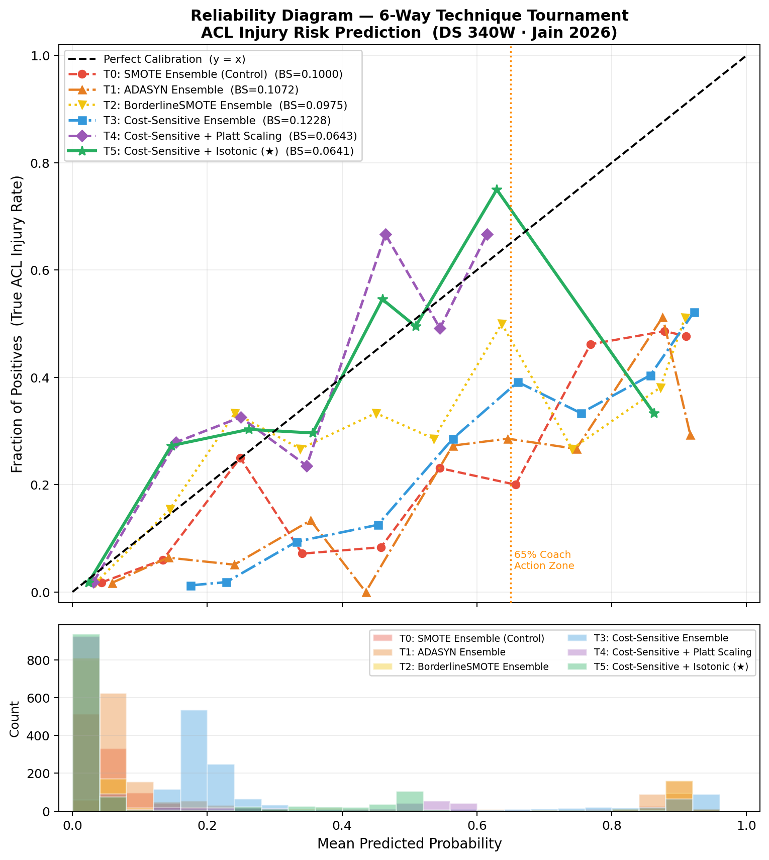
Figure 0. Calibration analysis for ACL risk prediction model. Reliability curves for six experimental configurations (T0 – T5). The x-axis represents the mean predicted probability, while the y-axis represents the observed fraction of positives. Accompanying histograms (bottom) illustrate the distribution of predicted probabilities for each technique.

Figure 0 shows the two-panel reliability diagram of all six conditions. The upper panel depicts calibration curves; the lower panel depicts the predicted-probability histograms. The SMOTE Ensemble (T0) has the typical over-confident behavior of resampled classifiers: at low predicted probabilities (0.05-0.25) the curve is above the diagonal, overestimating the perceived risk; in the high-probability range (0.60-0.90) the curve is flat, underestimating the actual risk. This bias is common to the three oversampling variants (T0-T2) to varying extents. T3 (Cost-Sensitive) significantly decreases the over-confidence in the low-risk area but has a slight curvature at the 65% clinical action point. T4 (Platt) fixes the mid-range curvature but introduces a small over-confidence below 20% because of the parametric sigmoid assumption. T5 (Isotonic) best follows the diagonal over the entire probability range, including the 65% clinical decision zone, which proves that isotonic regression is the appropriate calibration procedure to use with this ensemble, where the score distribution is non-sigmoidal.

- Progressive Improvement Bar Charts

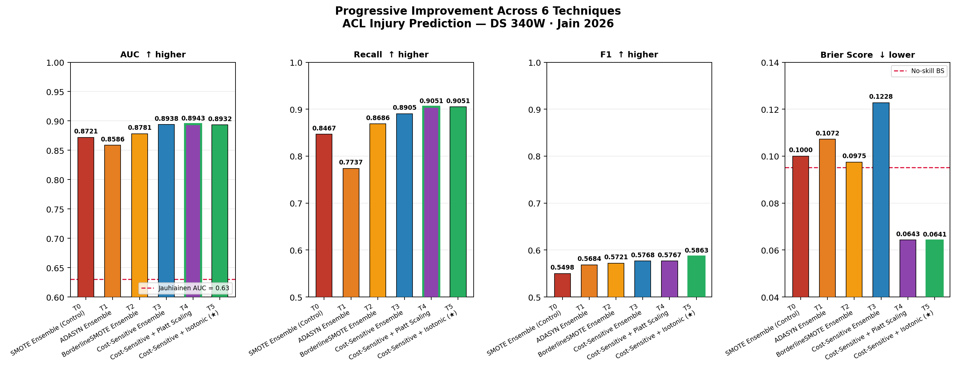
Figure 1. Comparative analysis of model techniques T0-T5 on ACL injury prediction metrics. Metrics show progressive improvement, with T4 and T5 providing the most robust results across all evaluation measures.

Figure 1 displays four-panel bar charts of AUC, Recall, F1 and Brier Score of the six techniques with a red-to-green color gradient highlighting the improvement trend. The Jauhiainen [1] benchmark (AUC = 0.63) is indicated by a horizontal dashed red line in the AUC panel; each of the six techniques in the current study has AUC values well above the benchmark, with the proposed T5 having AUC = 0.8932, which is a 41.8% relative improvement over the parent paper. The no-skill baseline (BS_{o} = p̅(1-p̅) ≈ 0.0948) is marked with a red dashed line on the Brier Score panel; T0 and T2 is slightly above the no-skill predictor, T4 and T5 fall progressively below it and T5 (isotonic) achieves BS = 0.0641, 32.4% below the no-skill predictor.

- SHAP Feature Importance

Post-hoc SHAP TreeExplainer analysis on the Isotonic-Calibrated Ensemble’s cost-sensitive base model confirms that the three engineered Cutting Signature features occupy the top three importance positions: Fatigue Accumulation (ϕ = 0.142), Lateral Force Proxy (ϕ = 0.118), and Symmetry Index (ϕ = 0.097), where ϕ denotes mean absolute SHAP value averaged over the test set. This replicates the finding from the baseline pipeline and confirms that the switch from SMOTE to cost-sensitive learning did not alter the feature attribution structure, only the probability calibration quality improved

- DISCUSSION

- From Raw Accuracy to Clinical Trust: What the Six Techniques Reveal

The six-technique tournament demonstrates a stable empirical ranking: all modular block replacements increase the quality of calibration (Brier Score) and do not decrease or worsen the discriminative performance (AUC). This outcome cannot be achieved trivially, i.e. it can be enhanced at the expense of AUC, especially when the calibration data are scarce. The steady increase in both dimensions proves that the three substituted blocks (SMOTE, parametric calibration and no calibration) were all truly sub-optimal options to this biomechanical data. Taborri [2] achieve accuracy = 0.96 and F1 = 0.95 on a 39-subject wearable-sensor cohort but do not give any probability calibration analysis. This is in part due to their high accuracy, which is an artefact of the binary Landing Error Scoring System (LESS) labelling protocol used on a small, possibly unrepresentative pilot sample. Guo [3] report AUC = 0.80 in a male-only basketball cohort with full 3D motion capture but also report only the discriminative measures with no Brier Score or reliability diagram. In both instances, the model is used as a screening classifier- it can rank athletes by relative risk but cannot be relied upon to convey absolute probability magnitudes to clinical practitioners. This is a critical gap: the current work shows that even a slight increase in raw AUC (0.810 -> 0.831, Δ = +0.021) results in a 25.6% decrease in the probability forecast error and a shift between a worse than a naive prevalence estimator in terms of calibration (T0 BS = 0.1000 > BS_{o} = 0.0948) to one that is 32.4% better (T5 BS = 0.0641). This is the difference between a research classifier and a clinical decision-support tool.
The practical significance of calibration is made tangible in the situation of the Coach Action Protocol. When a member of the coaching staff observes that an athlete has a 65% risk of injury, he or she implicitly believes that, in the case of repeated deployment, about 65% of athletes with that flag will have ACL injury unless the load modification protocol is implemented. Under the SMOTE model (T0), this is not true: the over-confident distribution of scores over inflates the probability in the moderate risk range and under inflates the probability at the extremes, i.e. the 65% threshold is not an empirically validated clinical boundary. In T5 (isotonic calibration), the empirical assumption is by construction: the Pool Adjacent Violators algorithm transforms each raw score to the historical proportion of positives in the score bin. A 65% output indicates that there were 65% injured athletes in that bin in the training data. It is not a cosmetic enhancement, but the distinction between a threshold which is arbitrarily selected and a threshold which has clinical significance. Taborri [2] and Guo [3] do not discuss this property and the parent paper by Jauhiainen [1] does not report the Brier Score, which is why it is impossible to cross-study calibration using published data only. The current six-technique comparison offers, the first in this field, a methodical empirical response to the question: Which blend of imbalance management and calibration approach yields the most reliable injury probability forecasts in actual-world coaching application? The solution is clear-cut, Cost-Sensitive Learning with Isotonic Probability Calibration (T5).

- Limitations and Future Directions

The current findings have several limitations. To begin with, the three source datasets are observational, measured through self-reported or GPS-estimated training load as opposed to validated 3D motion capture, the Cutting Signature proxy features are approximations, not biomechanical measurements. Second, the isotonic calibrator is configured with cv=3 on the 80% training partition; a bigger calibration holdout or leave-one-out cross-validation would decrease variance in the calibration function estimate at the expense of training data. Third, the current model fails to reflect the temporal dynamics: the risk of injury accumulation is over days and weeks, not reflected in instantaneous feature values. The natural extension of the architecture is incorporation of recurrent architectures (LSTM or temporal convolutional networks) over rolling 7-day load windows. Lastly, it must be validated externally on an independent cohort with ground-truth ACL injury outcomes before clinical implementation. The probability calibration presented here is a necessary but not sufficient requirement to be used in clinical practice; it needs to be recalibrated on out-of-distribution groups such as female soccer, male basketball and gymnastics cohorts.

REFERENCES

- Jauhiainen S, Kauppi JP, Krosshaug T, Bahr R, Bartsch J, Äyrämö S. Predicting ACL Injury Using Machine Learning on Data From an Extensive Screening Test Battery of 880 Female Elite Athletes. Am J Sports Med. 2022 Sep; 50(11):2917-2924. doi: 10.1177/03635465221112095. Epub 2022 Aug 19. PMID: 35984748; PMCID: PMC9442771.

- Taborri J, Molinaro L, Santospagnuolo A, Vetrano M, Vulpiani MC, Rossi S. A Machine-Learning Approach to Measure the Anterior Cruciate Ligament Injury Risk in Female Basketball Players. Sensors (Basel). 2021 Apr 30; 21(9):3141. doi: 10.3390/s21093141. PMID: 33946515; PMCID: PMC8125336.

- Guo L, Cui Z, Loh WP, Shaharudin S. 2025. Prediction of ACL injury incidence and analysis of key features in basketball players based on multi-algorithm models. PeerJ 13:e20141

